Naples (Southwest Florida) Weather Camps
Middle School start dates -- 6/29/20 and 7/27/20
High School start dates -- 6/15/20 and 7/13/20
Please read information carefully and type or print ALL information clearly in blue or black ink.
Please circle desired camp and start date: Middle School 6/29 7/27 High School 6/15 7/13

PERSONAL DATA
Student Name

[Last] [First] [Middle Name or Initial]
Current Address

Desired tee-shirt size (allow for possible shrinkage) |  | Date of Birth
Home Phone Number | Cell Phone Number | Student E-mail Address
Name of Parent/Guardian |  | Parent/Guardian Address (if different from Current Address)
Parent/Guardian Work Phone Number |  | Parent/Guardian E-mail Address

ACADEMIC STATUS (grade in upcoming school year):
In order to work more successfully with your child, we need to know if there are any learning, behavioral, and/or medical issues (These will NOT be used to exclude any child from the camp program, but rather help us accommodate individual learning needs). Please list and explain (use additional page, if necessary).

Career Interests (use an additional page, if necessary) |  |  | How did you learn about the SW Florida Weather Camp (e.g., school, science fair, organization [name], family, friend, flyer)?
I have read and understand the description and eligibility criteria for the SW Florida Weather Camp. I give camp directors and personnel permission to review this information. Further, I acknowledge that my camper must be a “responsible scientist.”

Parent or Guardian Signature:

Parent or Guardian Printed Name:
Date:

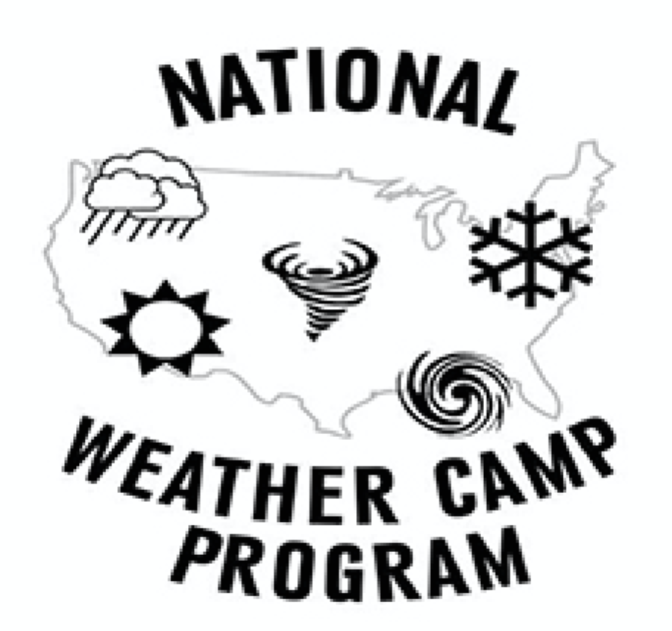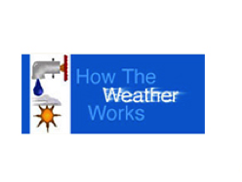

Please submit this application, along with a check or money order for $225 to How The Weatherworks, 814 Regency Reserve Circle #701, Naples, FL 34119. (239-529-1200; 240-426-2900 cell; 202-742-2806 (fax) E-mail weathercamps@weatherworks.com

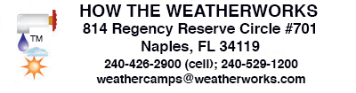

MODEL RELEASE

I, the undersigned, hereby grant H. Michael Mogil, Matt Bolton, and Barbara Levine (camp directors), and to their employees or assigns, permission to use photographs, digital images, and videos made during the dates/periods specified below. This includes images, videos, and other materials submitted by the camper and/or his/her family. Such use includes, but is not limited to, publication, display, advertising, editorial illustration, resale, and use in educational training programs. By signing, I understand that this release does not guarantee publication of the photo(s)/video(s).
This release does not transfer OWNERSHIP rights to How The Weatherworks. This merely allows How The Weatherworks to use the images and videos with appropriate permission.
These include images made at:

Southwest Florida Weather Camps - (Summer 2020)

of

Myself – parent/guardian (print full name)
My minor child(ren) (print child's full name, age, and relationship to signer) _________________
Property, including pets (identify by address or other description)
_____ ___________

Signature (I am over 21 years of age) ______
Today's Date / / 20
E-mail address
Mailing Address

5/17/20

